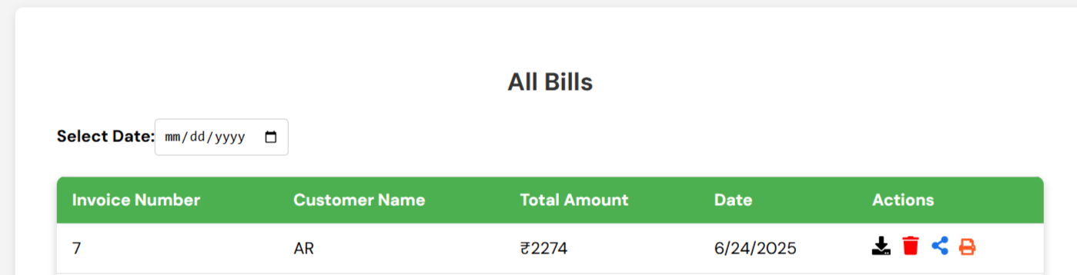

Invoice bill(remove all bills)

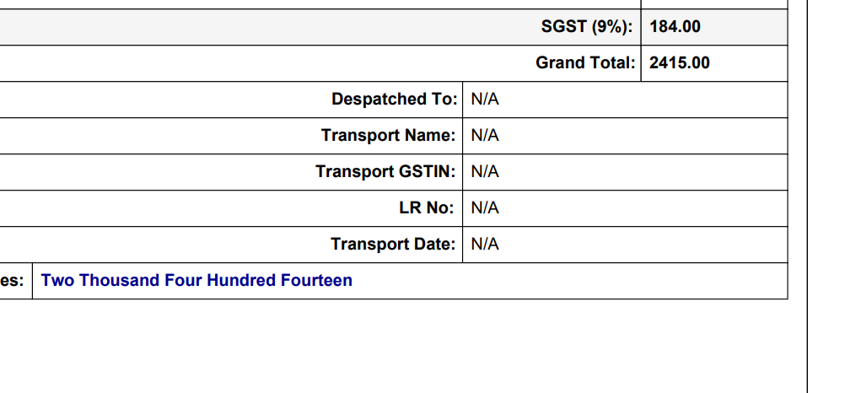

Transport Name

Dispatch From

Dispatch To

Remaining Remove